**Innovation, Employability Professional Readiness for**

**and Entrepreneurship**

ASSIGNMENT 1

SMART HOME

Submitted by,

Divya V

Reg No. 961819106020

Batch:- B12-6A2E

SMART HOME

CODE FOR SMART HOME:-

#include <Servo.h>

int site = 0;

Servo s;

void setup()

{

Serial.begin(9600);

s.attach(3,500,2500);

pinMode(11,OUTPUT);

}

void loop()

{

double a=analogRead(A0);

double t=(((a/1024)*5)-0.5)*100;

Serial.println('temp value');

Serial.println(t);

delay(1000);

if(t>120){

digitalWrite(11,HIGH);

site = 0;

for (site = 1; site <=180; site+=80){

s.write(site);

delay(100);

}

}

}

CIRCUIT DIAGRAM FOR SMART HOME:-

Tinker cad link: <https://www.tinkercad.com/things/hwuWb6T7861-smart-home>

SNAPS OF SMART HOME:-

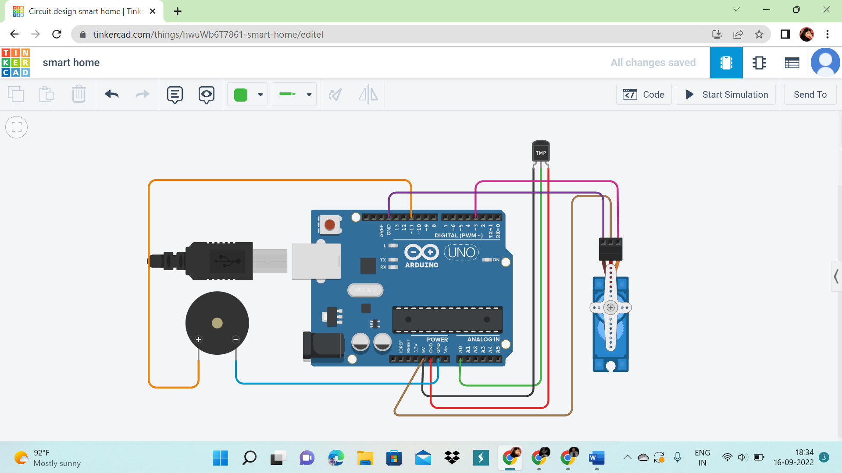

The above circuit diagram shows the smart home system in which TEMPERATURE SENSOR(Pin:A0-AnalogRead) acts as the fire detection sensor. When the temperature reading in the room is greater than certain value, the buzzer starts to beep till the temperature in the room goes down a threshold value and at the same time all the MICRO SERVO(Pin:3) which is acting as doors and windows opens, so that all the persons inside the house can escape through it.